* Topic & Background  
  : Redesigning the "Smart Campus(스마트캠퍼스)" application structure

: Main usability problmes => discoverability, simplicity, flexibility, consistency

* Purpose

1. Correction that causes cognitive errors (human error)

2. Adding a new function that considers the usability problems  
  
- 프로토타입  
(피그마 사진 첨부해주세요)

* Experiment (User Testing)

1. Participants: 20 people who use Smart Campus application  
1) Natural sciences : 8 people

2) Liberal arts: 8 people

3) Mixed: 4 people

2. Procedure

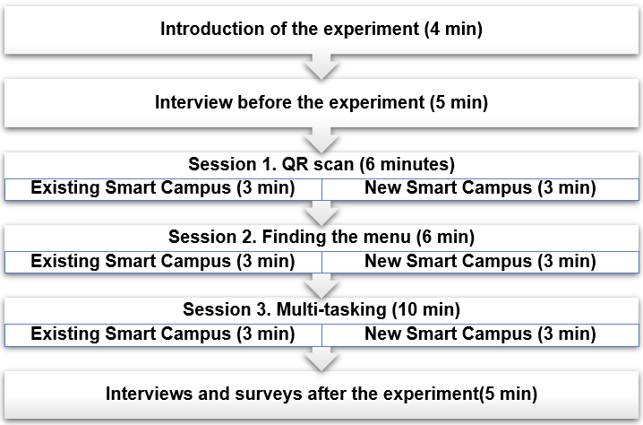

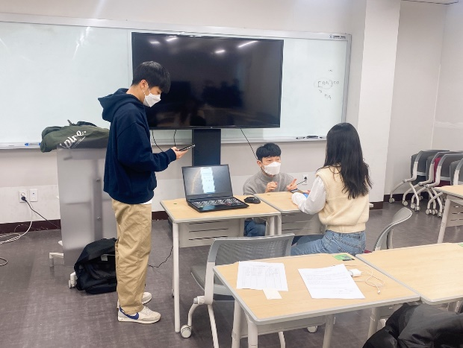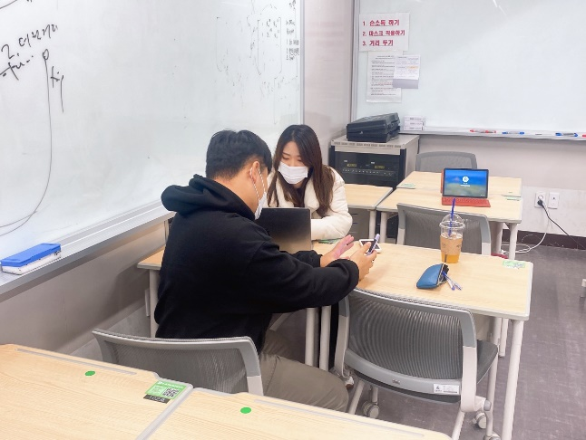

3. Measures

1) Quantitative: Time checking, Eye tracker, Survey

2) Qualitative: Pre-Post Interview

* Analysis

1) Quantitative Analysis

< Usability test chart >

1. Time on task  
:

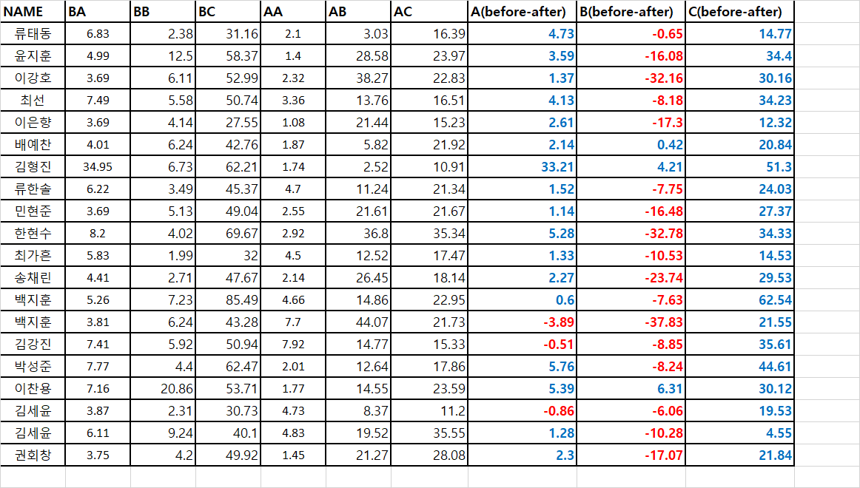

2. Satisfaction  
: 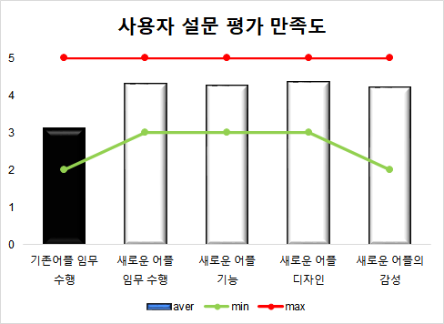

<Eye Tracker Data> : Task 2

1. Before

: 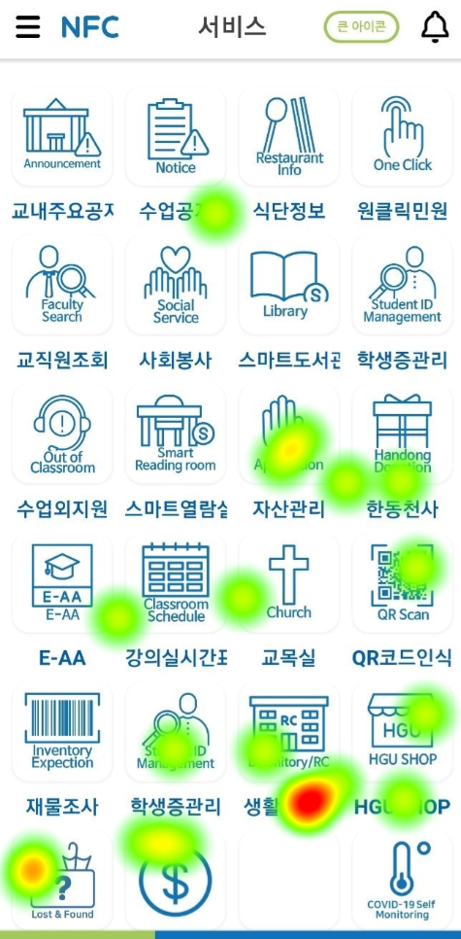

2. After  
: 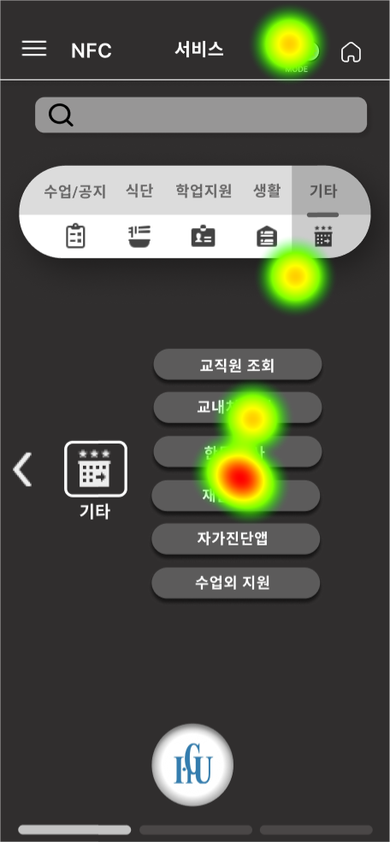

2) Qualitative Analysis

< Good >

|  |
| --- |
| 1. Able to customizing quick menu -> Useful |
| 2. Intuitive design -> able to access the function faster |
| 3. Category classification -> efficiency |
| 4. Darkmode -> relieves eye fatigue |

< Bad >

|  |
| --- |
| 1. Need detailed Information of icon |
| 2. Still too many functions |
| 3. Crawling doesn't work when it linked to Hisnet/Library |
| 4. Quick menus account for more than half |

* Conclusion

1. Contribution

: Collecting 20 handong students' opinions, finding problems of previous version of Smart Campus Application and proposing redesigned prototype and asking feedback and satisfaction level.

2. Limitation

- The design of prototype was more intuitive but as people adapted to the new design, it took more time and eye fatigue was higher in the eye tracker

- Accuracy of Eye tracker was low

3. Expected Further studies

- Provide detailed information of Icons for students who want intuitive information structure

- Reduce the number of functions that students do not use

- When Smart Campus Application linked to Hisnet/Library provide appropriate Crawling